Hitman card game

Game Design Document

Lucas Workman

**Overview**

**“**Hitman card game” is a 2d game built using pygame and the SimpleGE module

This is the idea behind the game: The game loads into a start scene where it tells you how to play. When you click play it takes you to a setting scene with settings to change the game. There will be a few parameters, such as cards being how many cards will be in the deck which is a slider element from 20 to 40 cards, how many hitman cards are in the deck, slider from 2 to 4 max, start with an angel card, which is a card you can play to survive a hitman card, and make that yes or no or a boolean variable. Once you finish changing the settings and want to start the Game scene, they click the play button to load that scene. Based on the settings it will be different, but the general idea for this scene is a table in a black room with the deck on the left and the played cards on the middle. You sit on one side of the table and your opponent (cpu) sits across from you. Your opponent will have a sprite to be visible.

Types of cards:

* Angel: You start with one of these cards unless your settings say otherwise. When you draw a hitman play this card to not die. 10% to draw a new one from deck
* Hitman: When you draw one of these cards its game over if you cant play an angel card.
* Arson: Randomly burn one of the other players cards
* Bottom Layer: When played, draw a card from the bottom of the deck instead of top
* Mine: Play this to randomly steal one of the players cards
* Shuffle: Play this to shuffle the decks order
* Seeing Eye: Play this to see the top 3 cards of the deck
* Copycat: Play this to get the same effect of the last played card

State Transition Diagram

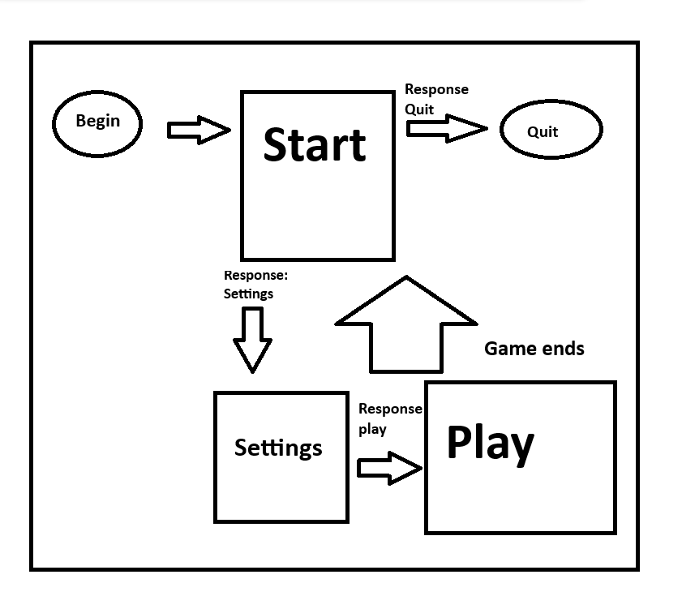

You start at the start scene when loaded. You are then given the instructions of how to play on this scene by using a multilabel. There are two buttons, one for settings scene that will say “Play” to avoid confusion for the user, and one that will say Quit to quit the program. Based on the click save the variable for the while loop inside main and use that to change all the scenes

**Instructions**

**How the game works**

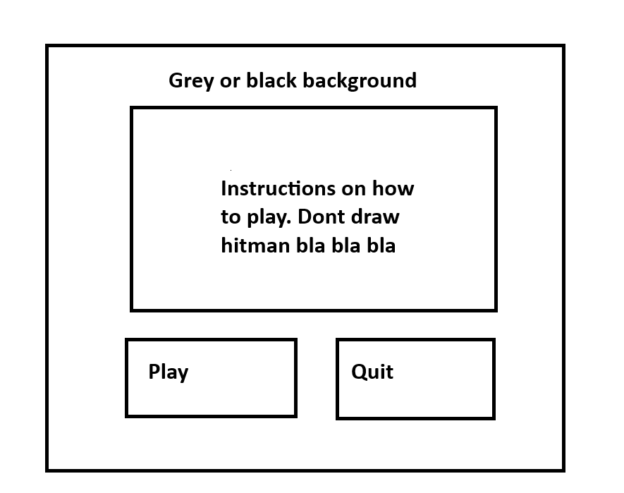

First scene shown when loading the game. It has a few key aspects to it

**Background-** just a basic fill background, preferably grey or black for ambiance. I may switch to a dark alley background depending on how it looks.

**Instructions-** Multilabel in the middle of the screen explaining how to play the game

**playBtn -** When clicked loads the Settings scene

**quitBtn -** when clicked quit the program by exiting the main loop

init():

Set the background to a grey or black color

Make a response variable

Create the instructions text

Center the instructions text

Make playButton

Make the playButton text say “Play”

Position it to where it is in the image

Make quitButton

Make the quitButton text say “Quit”

Position it where it is in the image

process():

If the playButton is clicked:

Response is play and will run the game scene and quit the current scene

If the quitButton is clicked:

Response is quit and quit the scene

**Settings Scene Class**

**Changes parameters for the game**

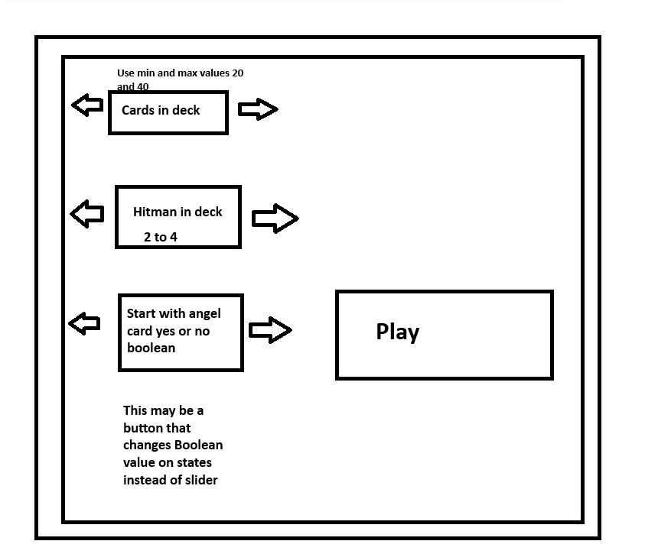

There are 4 main sprites in here, all being sliders except the angel one may change in the future Theres also the play button. These sliders change parameters that alter the game. When the play button is clicked it loads the actual game scene

Init():

Set the background to black color or grey

Make a variable called “cardsInDeck”

Make a variable called “hitmanInDeck”

Make a variable called “startWithAngel” starts as true

Add the play button

process():

If play button clicked:

Send the parameters

Response is game

**GAME CLASS**

The actual game

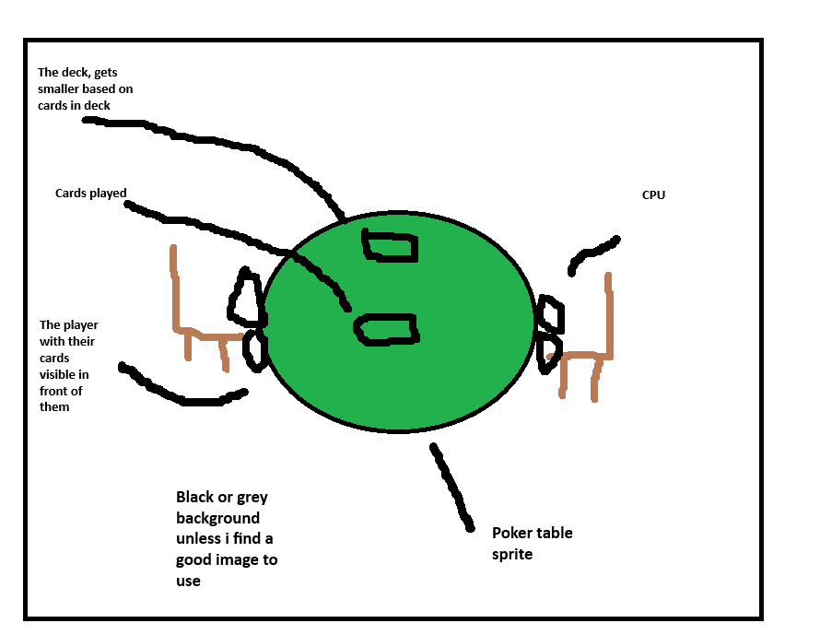

The main sprites in this scene are the table, the cards (8 different cards), the other player, maybe your hands on the table, the deck, the other players chair

Init(cardsindeck, hitmanindeck, startwithangel):

Background is either grey or black again

Make a dictionary that contains all cards including angel and hitman

Make a list that contains all the cards except angel and hitman

Position the table and other player in front of the player

Deck will be a button so we can check if it gets clicked or not

Make a list for player cards

Make a list for cpu cards

process():

For i in range hitmanindeck:

deck.append(hitman)

Cardsindeck -= 1

For i in range cardsindeck:

Rng = rand.randint(0,1)

For key, value in cardDict:

If value == Rng

deck.append(value)

(ok im not sure if this works as i just made the structure, but basically the dictionary acts as a way to change the chance of something, because with random everything has the same chance but i want angel to not have the same chance)

If startwithangel:

playerlist.append([wherever the angel is indexed])

cpulist.append([wherever the angel is indexed])

For i in range 5():

Cardchosen = random.randchoice(cardlist)

playerlist.append(Cardchosen)

cpulist.append(Cardchosen)

**Table Sprite**

Poker table image

Size is probably around 125x125 enough to fit in the middle of screen

Set position to middle

**Deck sprite**

This sprite has an image of a deck of cards, positioned to the left side of the player on the table

It will be a button to check for click

process():

If clicked:

Chosencard = random.choice(deck)

deck.remove(Chosencard)

playercards.append(Chosencard)

**Cpu Sprite**

This sprite is an image of some type of player, TBD

(i will also add a turn variable that is a boolean to determine if it's their turn to go or not, changes based on if they played a card or not)

process():

If turn:

Chosencard = random.choice(cpucards)

cpucards.delete(Chosencard)

**TextLabelCardsLeft**

Textlabel above the deck that tells you how many cards are left in the deck

**TextlabelCardsCPU**

Textlabel by the cpu cards to tell you how many cards they have

main():

The main loop of the program

Use keepgoing boolean and set to true

While keepgoing:

Load instruction scene

When instruction scene ends check for a response

If response is “Settings”:

load settings scene

If response is “Game”:

and load Game scene

Else:

Keepgoing = False

assets

hitmancard

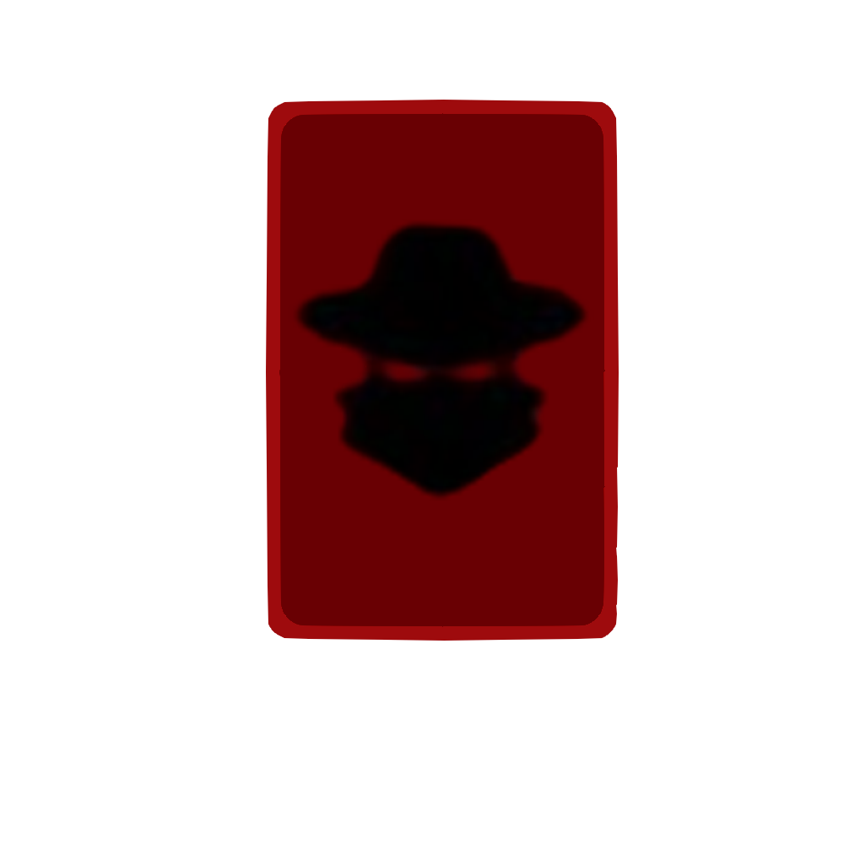

Poker table

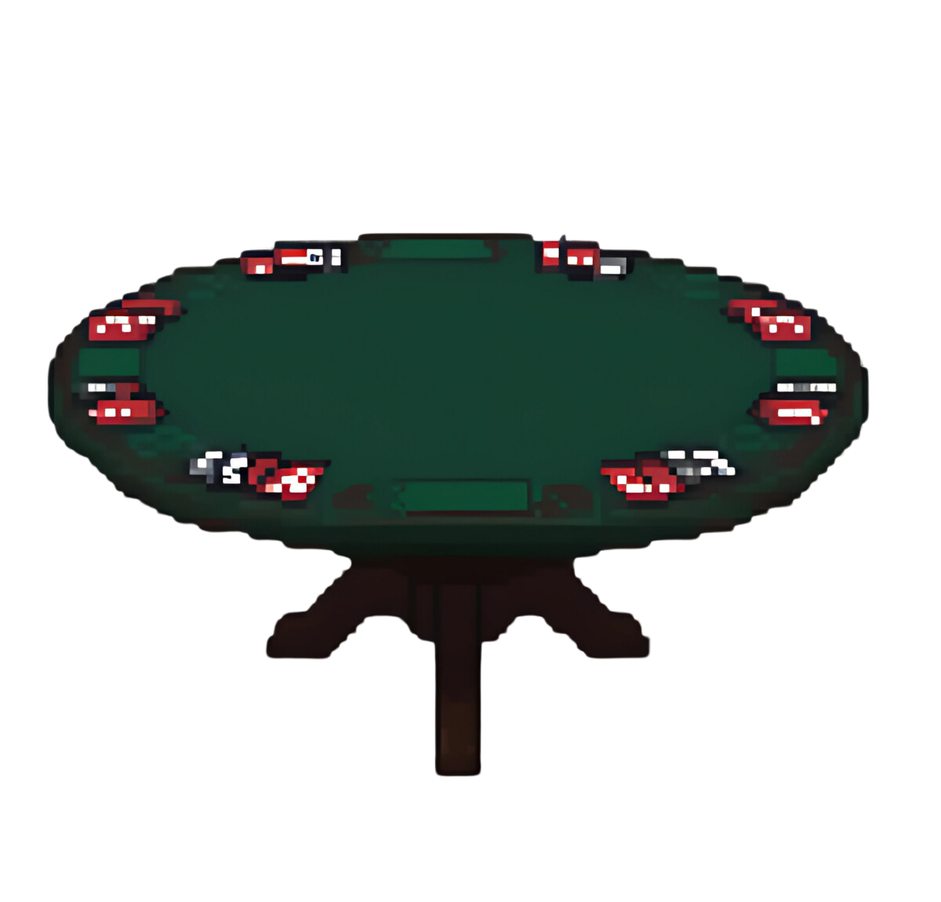

Hitman (CPU)

